**Technical Specifications Document for Weather App**

Revision History

| Approver Role | Name | Signature |
| --- | --- | --- |
| Integration Developer | Diway Sanu  [diwaygrover0019@gmail.com](mailto:diwaygrover0019@gmail.com)  <https://github.com/diwaygrover0019> | Version 1.0 |

**Contents**

Introduction 2

Assumptions 2

Environment Details 2

Prerequisites 2

REST API Endpoints 2

**GET /api/getCities** 2

**GET /api/getWeather** 3

Error Handling 4

API Architectural Flow and Capabilities 4

**Architecture flow** 4

**Project Capabilities** 5

**Jacoco** 5

**CompletableFuture** 5

**Reactive programming** 5

Unit Test Case 5

Enhancement 5

Challenges 6

References 6

# **Introduction**

Weather App exposes two REST endpoints, fetching data from downstream SOAP webservice (<http://www.webservicex.com/globalweather.asmx?WSDL>). Weather App is developed using Spring Boot, along with Web Flux.

# **Assumptions**

* Provided downstream service URL <http://www.webservicex.com/globalweather.asmx?WSDL> is not available. Instead we are using the NodeJS/Docker version of webservice.
* Extracted the provided zip, and ran the NodeJS service in my local machine.
* Provided NodeJS service response are not standard SOAP based response, so downstream data should always be per the mocks i.e.
  + getCities response is encapsulated content with **<![****CDATA[**content**]]>**
  + getWeather response is encapsulated content with **<![CDATA[<![CDATA[**content**]]>]]>**
* If content is not as per the mock, then exception will be raised and relevant message will be shown.
* The code should be deployed using JDK 8 or JDK 11.
* Apache CXF plugin has been used; alternate could have been Jaxb2 plugin.

# **Environment Details**

* spring-boot-starter-parent : 2.2.5.RELEASE
* JDK : 8/11
* Swagger : 2.0
* Apache CXF plugin : 3.3.5
* Jacoco : 0.8.1

# **Prerequisites**

* As external SOAP webservice is not available, NodeJS service has been deployed on local machine (<http://localhost:8080/GlobalWeather>), below are the steps:
  1. Extract the zip
  2. Run npm install
  3. Run npm start
* If you want to use different properties for different environments, e.g. for prod one can set spring.profiles.active=prod in application.properties file.

# **REST API Endpoints**

Weather App exposes below two REST endpoints:

## **GET /api/getCities**

*Description:* Get all the cities for the provided country name in query parameters. If the query parameter is not passed, API will give 400 (Bad Request) error.

*Query Parameter:*

|  |  |  |  |
| --- | --- | --- | --- |
| Parameter | Type | Required | Example and URI |
| country | String | Yes | country=Australia |

*Example URI*: <http://localhost:8081/api/getCities?country=Australia>

*Response Headers:*

Content-Type: **application/json**

*Response Body:*

Schema:

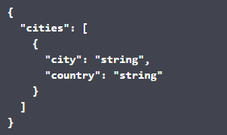

## **GET /api/getWeather**

*Description:* Get the weather data for the provided city name and country name in query parameters. If the query parameter is not passed, API will give 400 (Bad Request) error.

*Query Parameter:*

|  |  |  |  |
| --- | --- | --- | --- |
| Parameter | Type | Required | Example and URI |
| city | String | Yes | city=Sydney |
| country | String | Yes | country=Australia |

*Example URI*: <http://localhost:8081/api/getWeather?city=Sydney&country=Australia>

*Response Headers:*

Content-Type: **application/json**

*Response Body:*

Schema:

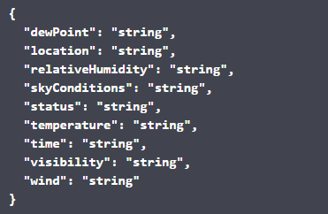

The **Swagger** is attached below for the above endpoints (if unable to open directly, please drag and drop):



# **Error Handling**

Weather App handles all major Exceptions including Runtime Exception’s. We have a customized **ErrorResponse** object which we return to the consumers of the APIs.

*Error Response Body:*

Schema:

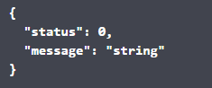

Implementation flow handles below error:

* **/api/getCities** and ***/api/getWeather***
  + 400 (Bad request) : “if user enters null or invalid query parameters”
  + 500 (Internal Server Error) : “if any unwanted exception occurs”
    - This includes any downstream error handling
    - Interrupted/Execution exception due to CompletableFuture
    - Marshalling Failure Exception

# **API Architectural Flow and Capabilities**

## **Architecture flow**

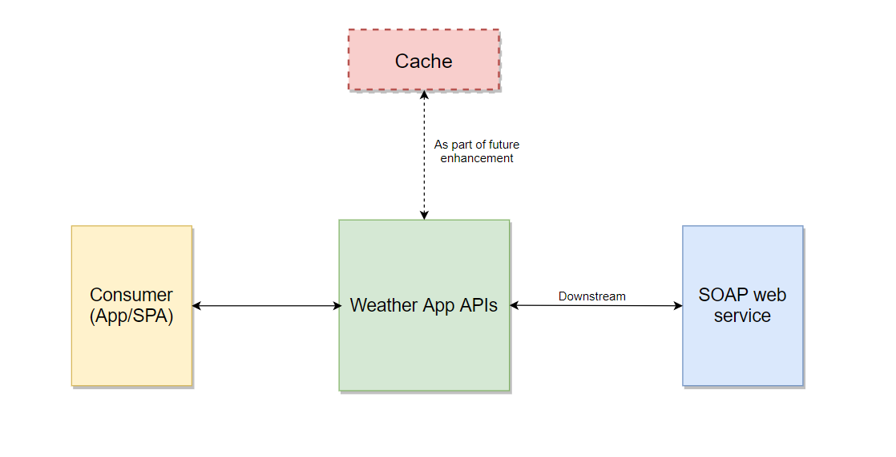

## **Project Capabilities**

The following additional features has been added to enhance application capabilities:

### **Jacoco**

* Jacoco plugin has been added to check code coverage.
* To run Jacoco plugin, run the below command:

mvn clean jacoco:prepare-agent install -Dmaven.test.failure.ignore=false

* The coverage report will be available at: /target/site/jacoco/index.html
* Please find below coverage report snapshot:

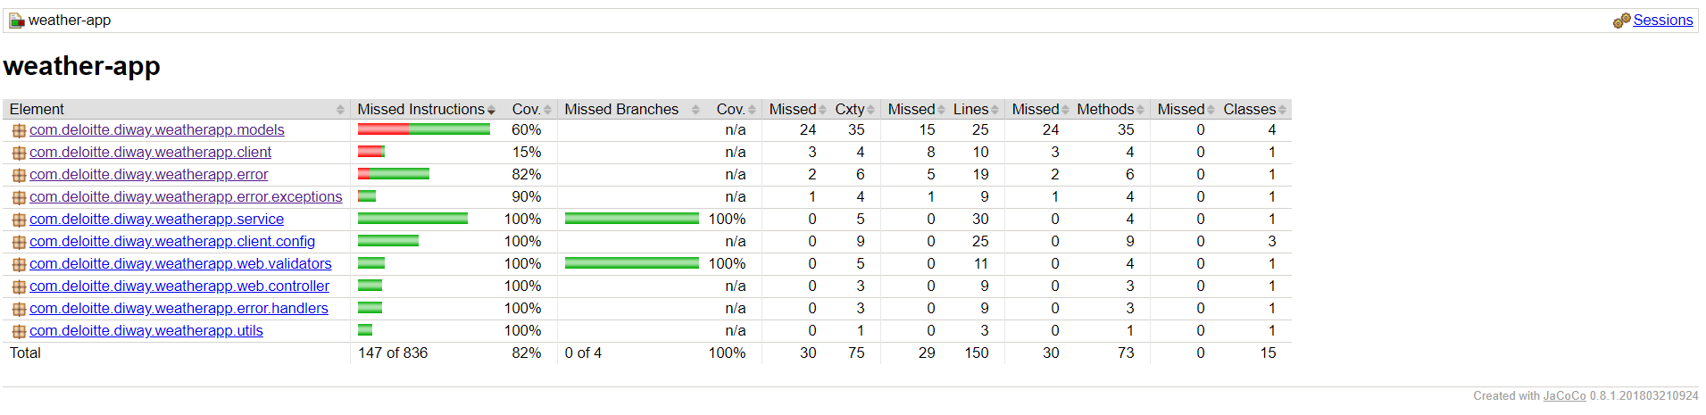

### **CompletableFuture**

* Any time-consuming task should be done asynchronously.
* CompletableFuture will run the task asynchronously, as we have supplied our custom executor to define the ThreadPool.

### **Reactive programming**

* Reactive programming requires achieving asynchronous, non-blocking functionality.
* We achieved partial reactive programming, as after we have got the downstream response, we are applying some transformation operations, which are kind of blocking practice.
* Post the transformation, we are returning model objects of type **Mono** for the consumers.

# **Unit Test Case**

* SpringBootTest has been used to cover the scope of integration tests.
* Junit and Mockito has been used to write unit test cases along with integration tests.

# **Enhancement**

* **Authorization** can be set on the APIs, which can be based on JWT, Oauth 2.0 or any other standard authorization architecture.
* **Cache** mechanism to save previous responses and use that when possible.
* Implement end-to-end reactive approach.
* Hystrix can be used to implement Circuit Breaker Pattern by failing fast in case downstream service goes down.
* **E2E testing** can be implemented instead of mock responses (currently in our code base).
* Implement better representation of the response data, e.g. setting extra attributes like correlation-id, timestamp, etc.

# **Challenges**

* Response from SOAP webservice is not standard xml response.
* Parsing the downstream response containing CDATA.
* Creating a common modify response method for both APIs as could see one of the API has CDATA embedded twice in response.
* Figuring out which plugin to be used, like Apache CXF or Jaxb2 to generate Java sources from wsdl.

# **References**

* <https://www.devglan.com/spring-boot/spring-boot-soap-client>
* <https://spring.io/guides/gs/consuming-web-service/>
* <https://stackoverflow.com/questions/23093897/sending-xmldata-in-soap-request-using-spring-ws>